AUTOMATED TRAFFIC LIGHT

Automated traffic light systems are an essential part of modern urban traffic management. These systems use various technologies to improve traffic flow, reduce congestion, and enhance road safety.

The components used in this project are:

Traffic Lights: These are the visual signals (red, yellow, green) that control vehicle and public.

Sensors: Various types of sensors are used to detect vehicles and the people moving around . These include:

* Inductive Loop Sensors: Embedded in the road, they detect the presence of vehicles by changes in inductance.
* Infrared Sensors: Detect motion and presence of vehicles and pedestrians using infrared light.
* Radar Sensors: Use radio waves to detect the speed and presence of vehicles.
* Cameras: Used for visual detection and monitoring of traffic conditions.

• Traffic Signal Controller: The hardware that controls the timing of traffic lights based on data received from sensors.

• Communication Systems: These systems allow traffic lights to communicate with a central traffic management system, other traffic lights, and emergency vehicles like ambulance.

• Central Traffic Management System: Software that collects data from various sensors and traffic lights, processes this information, and adjusts signal timings to optimize traffic flow.

Features of it:

• Adaptive Signal Control: Adjusts traffic signal timings based on real-time traffic conditions. This helps to reduce congestion and improve traffic flow.

• Pre-timed Signals: Traffic lights change at fixed intervals, which is suitable for predictable traffic patterns.

• Actuated Signals: Signal changes are based on vehicle and pedestrian detection by sensors.

• Priority Signaling: Provides priority to certain vehicles, such as emergency vehicles or public transportation, to reduce their delay.

• Pedestrian Signals: Special signals to ensure safe crossing for pedestrians, often with countdown timers.

• Integration with Traffic Management Systems: Allows for coordinated control of multiple traffic lights across a city to manage traffic more effectively.

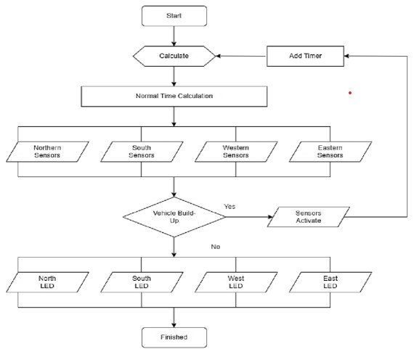

Summary:

An automated traffic light system uses sensors and software to manage the flow of vehicles and pedestrians at intersections. Sensors detect the presence of cars, bicycles, and pedestrians, and the system adjusts the traffic lights in real time to minimize delays and improve safety. The system can change light sequences based on traffic conditions, prioritizing emergency vehicles or buses when needed. By analyzing traffic patterns and using algorithms, the system aims to reduce congestion, save fuel, and decrease travel time. It replaces fixed timers, making traffic management more efficient and responsive to actual conditions.